**DEPARTMENT OF PRODUCTION ENGINEERING &INDUSTRIAL MANAGEMENT**

**COLLEGE OF ENGINEERING, PUNE**

(An Autonomous Institute of Govt. of Maharashtra)



**A SEMINAR REPORT**

**On**

**“A Bio-inspired Biped Robot with Variable Stiffness Actuator”**

**SUBMITTED**

**By**

**Ms. Owee Avinash Angare**

**T.Y. B.Tech. Production (Sandwich)**

**MIS NO: 111713005**

**UNDER THE GUIDANCE OF**

**Dr. (Mrs.) A. V. Mulay**

**Year**

**2019-2020**

**DEPARTMENT OF PRODUCTION ENGINEERING &INDUSTRIAL MANAGEMENT**

**COLLEGE OF ENGINEERING, PUNE**

(An Autonomous Institute of Govt. of Maharashtra)



**CERTIFICATE**

This is to certify that **Ms. Owee Avinash Angare** has completed the seminar entitled “**A Bio-inspired Biped Robot with Variable Stiffness Actuator**” in partial fulfillment of the requirement of the 5th semester of Production Engineering (Sandwich) course at the Department of Production Engineering & Industrial Management, College of Engineering, Pune, during the academic year 2019-2020.

Date: 6.12.2019 **Dr. (Mrs.) A. V. Mulay**

Place: Pune (Internal Guide)

Head,

Department of Production Eng. & Industrial Management,

College of Engineering, Pune

(External Examiner)

**AKNOWLEDGEMENT**

I am extremely grateful to the Department of Production Engineering and Industrial Management of College of Engineering, Pune for providing the necessary facilities towards the completion of my seminar study and report. I take this opportunity to extend my sincere thanks to Prof. Dr. Arati Mulay who guided me through the concepts of seminar which enabled me to do my best with practical understanding.

I express my sincere and profound gratitude to Prof. P. D. Pantawane, our Head of Department for his valuable encouragement, suggestions and advices for the preparation of the seminar. I thank all the teachers who have been a constant help for me, rendering their knowledge and skill which has certainly given me new ideas throughout this seminar.

I also like to thank my parents and friends for the constant encouragement and support in this venture, without whom I would have found it difficult to complete my seminar successfully.

**ABSTRACT**

Bio-inspired robotic locomotion has become immensely popular in the last two decades. Attempts to mimic biological principles behind animal motion have resulted in technological advances that have revolutionized manmade robots. It includes designing and building robots inspired by biological systems, which solve problems faced in engineering world.

Bipedal locomotion is a daily activity of humans. In contrast, in engineering field, agile and robust locomotion for biped robots in real world applications is still a challenging task. Studying and replicating the concepts of biological locomotors to robots with suitable changes, can enhance the performance and elevate the robot applications in daily life. Successful designs of biped robots have been achieved. However, major limitations like high-energy costs, poor robustness and dynamic instability on uneven terrain still prevail.

This seminar aims to provide a detailed study of the development of Biped Robots focusing on the design, stability, compliance and limitations of these robots in real environments. It also provides a case study including the mechanical design and experimental analysis of variable stiffness actuator used in a biped robot.

**CONTENTS**

|  |  |
| --- | --- |
|  |  |
| Page Title | Page No. |
| 1. **Introduction**: The concept of Biped-Robot | 3 |
| 1. **Literature survey**: Development in the design of biped robots in past 3 decades | 7 |
| 3. **Methodology**: Conceptual explanation and mechanical design of a variable stiffness actuator (VSA) | 10 |
| 4. **Case Study**: Biped Robot ‘Binocchio’ with VSA | 16 |
| 5. **Conclusion**: Conclusion to seminar report | 18 |
| 6. **Future Scope** | 19 |
| 7. **References** | 20 |
|  |  |
|  |  |

|  |  |  |
| --- | --- | --- |
| **Figure No.** | **Title** | **Page no.** |
| 1 | Zero Moment Point concept: Free Body Diagram (FBD) of foot during locomotion | 5 |
| 2 | Zero Moment Point concept: Forces on foot replaced by only 2 forces | 5 |
| 3 | Block Diagram of Series Elastic Actuator | 6 |
| 4 | Kinematic assembly of a conventional actuated joint in a Biped robot | 10 |
| 5 | Improved design of actuated joint in Biped-robot | 10 |
| 6 | Complete assembly of a variable stiffness actuator (VSA) | 12 |
| 7 | Mechanism of a VSA in equilibrium position | 13 |
| 8 | Slider-crank mechanism of the Driving mechanism of VSA | 13 |
| 9 | Working principle of Driving mechanism of VSA | 14 |
| 10 | Stiffening mechanism of a VSA | 15 |
| 11 | Biped Robot ‘Binocchio’ | 16 |
| 12 | Graph: Output torque as a function of angle α | 17 |
| 13 | Graph: Output stiffness as a function of angle α | 17 |
|  |  |  |
|  |  |  |
|  |  |  |
|  |  |  |
|  |  |  |
|  |  |  |
|  |  |  |
|  |  |  |

**CHAPTER 1**

**INTRODUCTION: THE CONCEPT OF BIPED-ROBOT**

Creating biped-robots which replicate animal locomotion with great efficiency has been a challenge before engineers since long in robotic research. The main aspects of human locomotion which makes it so versatile and energy efficient are dynamic stability and the intrinsic compliant properties of human joints and muscles. Due to these properties, humans can adapt to natural environments and uneven terrains providing safe and stable locomotion.

Over the last few decades, many designs for biped-robots have been proposed and implemented, which try to replicate the properties of human locomotion. Zero moment point (ZMP), passive dynamic walking and series elastic actuation, were the major concepts behind these designs. Although the current biped robots based on these designs, fulfill the requirements of locomotion on flat terrains, their performance decreases on uneven terrains with unnatural surroundings. They contain joints with stiff actuators that lack the property of compliance. Due to this, the robotic joints cannot adjust the stiffness and cannot adapt to unpredictable environments.

**A. Human Locomotion**

Human locomotion emerges as a result of neural, mechanical and morphological aspects. This helps achieve robust, versatile and energy efficient locomotion in a vast range of conditions. Compliance, which is the flexibility of physical structures in response to an external force, is an important property of human locomotion. It is achieved by the visco-elastic properties of muscles (agonists and antagonists) and joints, and series-elastic tendon structures. Compliance helps the muscle-joints to vary the stiffness in accordance to the external conditions. It provides fast storage and release of energy when required by the muscles. Compliance also facilitates proper reaction to sudden impacts without losing dynamic stability.

**B. Mechanics of Human Locomotion**

Human leg stiffness is independent of speed and gravity. It depends on the inherent musculoskeletal properties. The muscles, tendons and ligaments behave as a single linear spring and mass system with the mass equivalent to the human’s mass. Human locomotion takes place on a wide variety of terrains; flat, uneven, smooth or filled with obstacles. The magnitude of the reaction force provided, depends on the compression factor of these terrains. Human locomotion on these surfaces can be viewed as the leg spring in series with the surface spring. The adjustable stiffness of this spring-mass system helps to achieve speed and agility in human locomotion.

**C. States of Compliance in Human Locomotion**

1. Motive State

Internal muscle forces are used to accelerate the joint motion using agonist muscles, which cause a movement to occur through their own activation.

2. Resistive State

Internal forces are used to decelerate joint motion against external forces using antagonist muscles, which produce opposing torque to agonist muscles.

3. Stabilizing State

It is a state in which internal forces are used to counteract external forces to maintain the joint in a fixed position, It occurs by the contraction of agonist and antagonist muscles.

4. Passive State

No internal forces are produced in this state. The joint is free to move under the effect of inertial and gravitational forces. Muscles are not activated.

**D. Control and Feedback in Human Locomotion**

The neuromuscular mechanism is responsible for control and feedback. It mainly consists of ‘afferent nerves’, which receive information (feedback) from our sensory organs and transmit it to the central nervous system, and ‘efferent nerves’, which send impulses (control) from the central nervous system to the limbs and organs. The neural activity controls the mechanical output of muscles that is the visco-elastic and series-elastic properties. The muscles further interact with the external environment which provides compliant human locomotion.

**E. Zero Moment Point (ZMP)**

One of the important aspects of human locomotion is ‘dynamic balance’ or ‘dynamic stability’. Considering the foot as a system, the forces and moments which act on it are as follows.

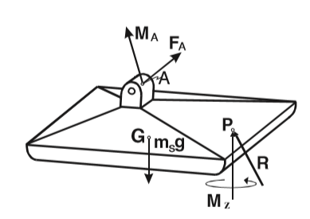 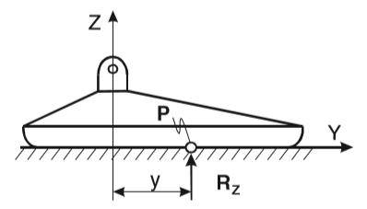

Fig. 1 FBD of foot in locomotion Fig. 2 ZMP concept

In Fig. 1, point A represents the link between foot and ankle.

FA and MA represent the force and moment acting on the foot due to the mechanism of the leg above the ankle. G is the centre of gravity, msg is weight of the foot and R is the normal reaction of the ground on the foot at a point P.

R is divided into 3 components; Rx, Ry and Rz. Rx and Ry are the horizontal components of force R which balance the horizontal component of force FA.

Also, moment MZ balances the vertical component of force FA and moment MA.

From Fig.2, the two unbalanced components on the foot are the horizontal component of moment MA (MAx) and vertical component of force R (RZ).

For dynamic equilibrium, the reaction of the ground on the foot can be replaced by only vertical component of R (RZ) and MZ at a point P and this point is called ‘Zero Moment Point”.

There are certain limitations to the ZMP concept, as it only talks about the dynamic stability of locomotion but fails to consider the compliance property (adjustable joint stiffness) and high energetic costs of walking.

**F. Passive Dynamic Walking**

ZMP concept provided detailed analysis of dynamic stability of locomotion. However it neglected the high energetic costs of walking. A probable solution to this was provided in the concept of passive dynamic walking. The concept stated that, gravity and inertia alone generate the locomotion pattern which is called as ‘passive walking’. It provided a biped-robot which once started on a shallow slope could continue its steady gait without active control or energy input. This concept provided mechanical simplicity, relatively high efficiency and easy control of speed and direction of locomotion. However, it was unsuitable on flat, uneven terrains and this concept also neglected the compliance property to adjust joint stiffness.

**G. Series Elastic Actuators**

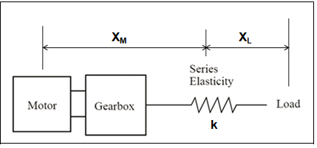

Fig.3: Block Diagram of SEA

It was the first concept to take into consideration the compliance properties of locomotion. SEA consists of an elastic element in series with the mechanical energy source. It introduced compliance to biped-robots, resulting in force control, increased shock tolerance and greater efficiency in non-structured environments. It works on force control by Hooke’s law.

F (out) = k * (XM – XL). Where, XM and XL are positions of motor and load, and k is the stiffness of the spring. XM and XL can be controlled using a position controller, thereby controlling the output force and in turn the stiffness of the joint.

The main problem with the current biped-robots is their inability to achieve good performance in real world environments, as the joints in these robots lack the property of compliance. The probable solution to the current problem is cautiously incorporating adjustable compliant actuators (variable stiffness actuators) in the design.

The seminar report provides the concept and mechanical design of a VSA as a solution to the limitations present in the current design concepts of Biped-robots, focusing on **variable stiffness actuators (VSAs).**

**CHAPTER 2**

**LITERATURE SURVEY: DEVELOPMENTS IN DESIGN OF BIPED ROBOTS**

Many research workers have invented and demonstrated various design concepts for efficient biped-robot locomotion. The literature describing the development of biped-robot locomotion, till the development of the solution to the current problem has been discussed below.

**Ichiro Kato, (1984)[1]** put forth the ﬁrst practical demonstration of Zero Moment Point concept (ZMP) in Japan in 1984, at Waseda University, laboratory of Ichiro Kato, in the ﬁrst dynamically balanced robot WL-10RD of the robotic family WABOT. However, ZMP concept did not clarify the high energy costs and reduced performance on uneven terrains for the biped robot.

**Tad McGeer, (1990)[2]** stated that, there exists a class of two-legged machines, for which walking is a natural dynamic mode. He talked about ‘passive dynamic walking’ which had low energy costs and once started on a shallow slope could continue its gait cycle without energy input. He also conducted experiments to verify that passive walking can be readily exploited in real environments. This study put forth a solution for the high energy costs of locomotion. However, it did not explain why the performance of the robots decreased with uneven terrains.

**Farley and Gonzales, (1996)[3]** presented the idea, that when humans and other mammals run, the body’s complex system of muscle, tendon and ligament behaves like a single linear spring (‘leg spring’). They concluded from their study, the stiffness of the leg spring remains nearly the same at all speeds and that the spring-mass system is adjusted for higher speeds by increasing the angle swept by the leg spring. This provided the first input to the property of ‘compliance’ in human locomotion.

**Ferris, Louie and Farley (1998)[4]** in their study presented that, a running animal coordinates the actions of many muscles, tendons, and ligaments in its leg. They found that human runners adjust their leg stiffness to accommodate changes in surface stiffness, allowing them to maintain similar running mechanics on different surfaces. These results provided important insight into the mechanics and control of animal locomotion and suggested that incorporating adjustable leg stiffness in the design of hopping and running robots is important if they are to match the agility and speed of animals on varied terrain.

**Hobbelen D.G. and Wisse, (2005)[5]** proposed that, one of the difficulties with passive dynamic walking was the stability of walking. Small uneven or tilted parts of the floor could disturb the locomotion and had to be dealt with by feedback controller.

**Vanderborght, Van Ham, Verreslt, Van Damme and Lefeber (2008)[6]** presented overview of ‘Lucy’ project. They proposed a new concept of dynamic stabilization of a biped robot powered by pneumatic artificial muscles. This was the first time ‘compliance’ of joints was taken into consideration while designing a biped robot.

**Vanderborght, Albu-Schaeffer, Bicchi, Burdet, Caldwell, Carloni (2013)[7]**

Series Elastic Actuators (SEAs) were first mentioned by Pratt and Williamson in 1995. However in 2013, they presented an overview of the different Variable Impedance Actuators (VIAs) developed and proposed a classification based on the principles through which the variable stiffness and damping were achieved.

**Huang, Vanderborght, Van Ham, Wang, Van Damme, Guangming (2013)[8]**  designed and created the bipedal robot ‘Veronica’, in which passive walking was enhanced by providing compliance to the joints. Veronica was built to analyze the relation between joint compliance and walking characteristics.

[**Rodriguez-Cianca**](https://www.frontiersin.org/people/u/665307)**, Weckx,**[**Jimenez-Fabian**](https://www.frontiersin.org/people/u/370792)**,**[**Torricelli**](https://www.frontiersin.org/people/u/117089)**,**[**Gonzalez-Vargas**](https://www.frontiersin.org/people/u/245017)**, M.Carmen Sanchez-Villamañan, Sartori, Berns, Vanderborght,**[**J. Luis Pons**](https://www.frontiersin.org/people/u/85742)**and Lefeber (2019)[9]** proposed, achieving human-like locomotion with humanoid platforms often requires the use of variable stiffness actuators (VSAs) in multi-degree-of-freedom robotic joints. The design of the VSA module is presented, including it’s mechanical design. The mechanisms of the driving and stiffening mechanisms are given. Experiments validated the static characteristics of the VSA module to accurately estimate the output torque and stiffness.

The Bipedal Robot design developed from a simple design based on Zero Moment Point (ZMP) concept to the latest technology incorporating Variable Stiffness Actuators which provide compliance and dynamic stability to the biped locomotion providing a solution for the problem, of low performance on uneven terrains and unnatural surroundings, faced in the traditional design of biped-robots.

The next chapters focus on the design and experimental validation of a Biped-Robot with VSA.

**CHAPTER 3**

**METHODOLOGY: CONCEPTUAL EXPLANATION AND MECHANICAL DESIGN OF A VARIABLE STIFFNESS ACTUATOR (VSA)**

The VSA actuator presented in this work is based on the MACCEPA (Mechanically Adjustable Compliance and Controllable Equilibrium Position Actuator) concept.

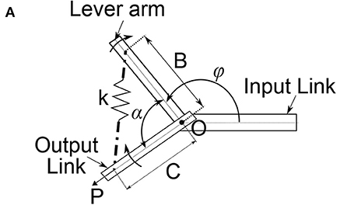

Fig. 4 Traditional actuated joint design

Fig. 4 shows the kinematic assembly of a conventional actuated joint in a Biped robot. The elastic element (here, spring) spans the actuated joint.

The spring is housed on the output link. Thus, the mechanism to drive the lever arm and the one to change the pre-compression of the spring are on different links (Input and Output link respectively) which serves as a disadvantage.

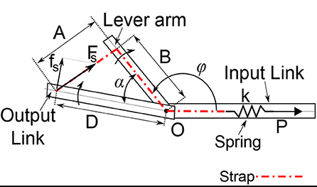

Fig. 5 Improved design of actuated joint

Fig. 5 shows a novel concept of the design of actuated joint in Biped-robot.

In this design, the elastic element is housed in the input link, due to which, both mechanisms to drive the lever arm and the one to change the pre-compression of the spring are on the same link.

Conceptual explanation of the VSA:

Strap is attached to the Output link at a distance D from the centre of rotation O.

From the Output link, the strap is taken through the Lever arm and guided through O to the linear spring housed in the input link and rigidly attached to it.

Working of the novel actuated joint design is as follows.

When Output link and Lever arm are aligned, the force exerted by the strap is balanced by the initial deformation or pre-compression of the spring. Thus, no torque is exerted on the output link.

When the output link and the lever arm are not aligned and make an angle (α not equal to zero), then the deformation of the strap exerts a force on the spring (FS).

FS is no longer aligned with output link; therefore it is acted upon by a torque.

If pre-compression force P of the spring is changed, stiffness at the outer link can be adjusted.

The actuator's output torque and stiffness characteristics can be easily and accurately predicted using only the deviation angle α, and the force in the strap, FS or the spring linear deformation, p induced by the compression, or stiffening mechanism.

Mathematical explanation:

T = T (α, p) = D⋅fs

(Torque at the output link is a function of the angle ‘α’ and the linear deformation of the spring ‘p’. Torque is perpendicular distance into force, here fS is the perpendicular component of force FS)

T = k*p(t)* B*D* sin(α) …. (fS = k*p(t))

A(α)

A(α) = √B2+D2−2BD*cos(α)

is the length between the attachment points of the strap at the output link and the lever arm.

Stiffness (S) is given as torque (Nm) per angle (deg).

Since torque and angle change with time,

S = dT

dα

Force FS can be easily calculated from the spring stiffness k and the angle α is also known. Thus, stiffness S at the output link can be easily found out. Using a feedback system, stiffness S can be altered according to convenience.

Mechanical Design of the VSA:

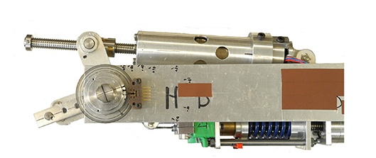

Fig. 6 Complete assembly of VSA

Fig. 6 shows the complete assembly of a variable stiffness actuator (VSA).

The design of a VSA is primarily divided into two main mechanisms.

1. Driving Mechanism

This mechanism defines the position of the lever arm.

2. Stiffening Mechanism

It serves 2 purposes. It detects any deviation in the angle α between the output link and the lever arm by deforming the spring in the input link. And it also adjusts the compliance at the output link by setting the initial deformation of the spring.

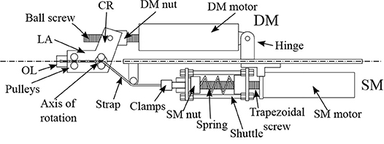

Fig. 7 Mechanism of VSA in equilibrium position

Fig. 7 shows the Mechanism of a VSA in equilibrium position, when angle between output link and lever arm is zero.

Abbreviations:

DM: Driving Mechanism, CR: Crank, LA: Lever Arm, OL: Output Link

SM: Stiffening Mechanism

**Driving Mechanism of VSA**

It primarily is a slider-crank mechanism as shown in Fig.7

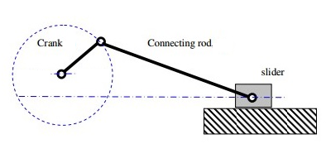

Fig. 8 Slider-crank mechanism for driving mechanism of VSA

Slider: A motor and drive spindle inside a housing mounted on a spindle screw. It is hinged at one end with respect to the input link

Connecting Rod: Spindle Nut

Crank: Crank which is connected to the spindle nut and is rigidly attached to the Lever arm

The length of the slider is determined by the distance between the crank-nut connection and the hinge point. Thus, as the nut performs translational motion, the length of the slider varies accordingly.

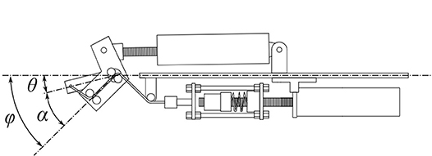

Fig. 9 Working principle of driving mechanism of VSA

The spindle drive rotates and the rotational motion of the motor is converted to the translational motion of the nut. As the position of the crank-nut connection changes, the length of the slider changes resulting in rotation of the crank. This in turn alters the angular position of the lever arm. Thus, the lever arm receives a torque due to which the initial zero angle between LA and OL changes to some angle, α (Fig.9). The driving mechanism thus provides a degree of freedom to the actuated joint and can rotate the OL and LA to desired position.

The free end of the OL is attached to a strap, which has high heat resistance and strength. This strap enters the LA through a pair of pulleys and is guided by another set of pulleys through the joint’s axis of rotation. The strap then enters the input link and is in contacted with the Stiffening Mechanism of the VSA.

**Stiffening Mechanism of VSA**

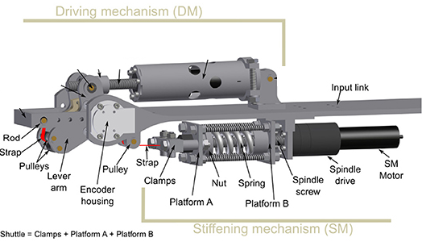

Fig. 10 Stiffening mechanism of VSA

The stiffening mechanism of a VSA consists of a system which transforms the angle α between OL and LA into a deformation of the spring.

It consists of a motor and a spindle drive attached to the input link. The position of the spindle screw can be varied using the motor and the drive.

The Stiffening mechanism consists of a shuttle which has clamp with two platforms, Platform A and Platform B as shown in Fig.10 . The strap is attached at Platform A and the spring to Platform B. The shuttle can also perform linear motion along the spindle.

As the crank of the driving mechanism rotates, the angle between the OL and LA, which initially was zero, changes to some angle α, as discussed in the previous section. Due to this, the strap pulls the shuttle and in turn compresses the spring. The force exerted by the strap (which depends on the spring stiffness, ‘k’) is not aligned with the OL. This creates a torque at the axis if rotation of the joint which tries to re-align OL and LA.

If the pre-compression of the spring is controlled, the amount if torque is controlled which in turn controls the stiffness of the joint at the output link. The pre-compression of the spring can be controlled by changing the position of the spindle screw using the motor and the spindle drive. As the screw is directed away from the motor, a force parallel to the screw acts on the spindle, producing pre-compression in the spring.

**CHAPTER 4**

**CASE STUDY: BIPED ROBOT ‘BINOCCHIO’ WITH VSA**

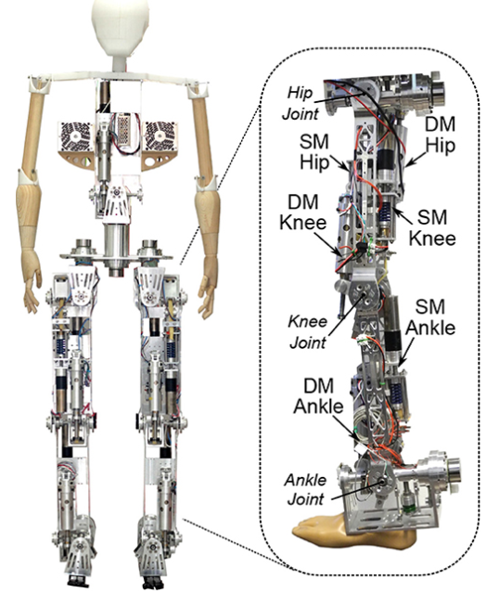

Fig.11 Biped Robot ‘Binocchio’

Binocchio is a biped robot with the latest technology of variable stiffness actuators (VSA) along with series elastic actuators (SEA) implemented in it. Fig. 11 shows the structure of Binocchio’s leg. It consists of one SEA on ankle, one VSA in shank, two VSAs in thigh, one SEA on hip and one SEA in trunk.

The material employed for most parts of VSA is aluminum, while the joint’s centre of rotation is made from stainless steel. The actuator’s total weight is 1.2 kg and it can generate a maximum output torque of 40 Nm. Length of the lever arm is 46.7mm. The maximum compression in spring is 21.7 mm with stiffness 68.7 N/mm, which results in a maximum force in strap of around 1500 N. The strap used is made from Kevlar fabric.

**Experimental Validation**

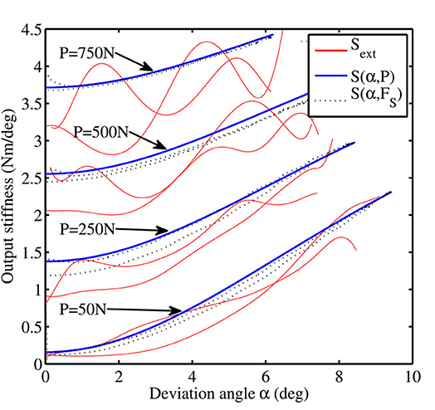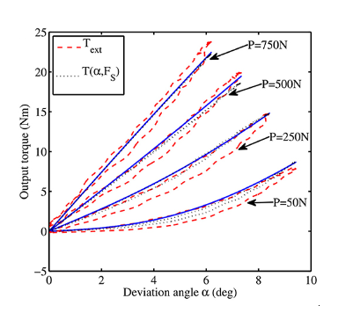Experiments were conducted to test whether the proposed theoretical values of output torque and stiffness (which depend on angle,α) matched with the actual values measured during the experimental analysis.

Fig.12 Fig.13

Output torque as function of α Output stiffness as function of α

The initial compression of the spring is kept constant and the angle α is changes. (Fig. 12). Corresponding actual values of output torque are obtained. The comparison between the actual values and theoretical values shows an error of only 6.1%.

The output stiffness, for different values of initial compression of spring, is noted. The experiment shows a tendency similar to that obtained by the theoretical estimation, showing a stiffness increases as both the initial spring deformation (*P*) and deviation angle (α) values increase.

The experiment validates that it is possible to control the stiffness of robot joints using variable stiffness actuators with only 6% error. VSAs provide a novel solution to the traditional robot joint designs which lack compliant properties. VSAs thus provide dynamically stable, efficient and compliant joint actuation.

**CHAPTER 5**

**CONCLUSION**

The whole study was done by extensive survey of bio-inspired biped-robots joints design along with a particular case study of the Biped-robot ‘Binocchio’. The study emphasized on the evolution of the biped-robot joints design from the humble Zero Moment Point (ZMP) concept to the latest Variable Stiffness Actuators (VSA) which has revolutionized the robotic locomotion field.

In this study, it was found that the classic zero moment point (ZMP) concept paved the way for the modern biped-robots. The only limitation in ZMP notion was the high energy costs and low performance in unnatural surroundings. The study further revealed the theory of ‘passive dynamic walking’ which lowered the energy costs of locomotion of the robots. The seminar study further focused on human locomotion and the concept of ‘spring-mass system of leg’ which introduced the inherent compliant properties in humans which is the foundation of the modern biped-robot designs.

This work presented the study of a novel solution to the problems, like dynamic instability and lack of compliant properties, faced by the traditional designs. It also provides the mechanical design and mathematics behind the VSA. An experimental investigation on the biped-robot ‘Binocchio’ is also made and presented towards the end of the report. Through the experiment it is validated that VSA can control the output torque and stiffness with only 6% error. The variable stiffness actuator has a great potential to revolutionize the field of biped robots.

**FUTURE SCOPE**

Bio-inspired biped robots are becoming technologically advanced to show good performance even in unstructured dynamically changing surroundings.

These robots with VSAs and compliant joint properties show great abilities to be used in environments which are dangerous for human locomotion. Be it bomb defusing squad or mining operation, these advanced biped robots can replace humans to perform dangerous tasks. Due to their ability of adjusting joint stiffness the robots can also be used in future for medical surgeries or as prosthetics which involves intricate, accurate work.

The attempts to replicate animal motion have been successful so far, however, engineers are yet to completely understand and apply the various biological principles behind animal locomotion. For example, looking at snake locomotion, on the superficial side, it is an animal that crawls on the ground using its muscles. However, on deeper level one can study the fundamental macroscopic principles that can be transferred from muscles and skeleton to conventional motors and mechanical linkages.

Thus there is still a scope of immense improvement in design of biped-robots inspired from biological principles.

**REFERENCES**

[1] Vukobratović, M., and Borovac, B. (2004). Zero-moment point-thirty five years of its life. Int. J. Human. Robot. 1, 157–173.

[2] McGeer, T. (1990). Passive dynamic walking. I. J. Robotic Res. 9, 62–82.

[3] Farley, C., and Gonzalez, O. (1996). Leg stiffness and stride frequency in human running. J. Biomech. 29, 181–186.

[4] Ferris, D., Louie, M., and Farley, C. (1998). Running in the real world: Adjusting leg stiffness for different surfaces. Proc. R. Soc. Lond B Bio. Sci. 265:989–994.

[5] Hobbelen, D. G., and Wisse, M. (2005). “Ankle joints and flat feet in dynamic walking,” in Climbing and Walking Robots (Berlin; Heidelberg: Springer), 787–800.

[6] Vanderborght, B., Van Ham, R., Verrelst, B., Van Damme, M., and Lefeber, D. (2008). Overview of the Lucy project: dynamic stabilization of a biped powered by pneumatic artificial muscles. Adv. Robot. 22, 1027–1051.

[7] Vanderborght, B., Albu-Schaeffer, A., Bicchi, A., Burdet, E., Caldwell, D., Carloni, R., et al. (2013). Variable impedance actuators: a review. Robot. Auton. Syst. 61, 1601–1614.

[8] Huang, Y., Vanderborght, B., Van Ham, R., Wang, Q., Van Damme, M., Guangming, X., et al. (2013). Step length and velocity control of dynamic bipedal walking robot with adaptable compliant joints. IEEE/ASME Trans. Mech. 18, 598–611.

[9] [Rodriguez-Cianca](https://www.frontiersin.org/people/u/665307), Weckx, [Jimenez-Fabian](https://www.frontiersin.org/people/u/370792), [Torricelli](https://www.frontiersin.org/people/u/117089), [Gonzalez-Vargas](https://www.frontiersin.org/people/u/245017), M.Carmen Sanchez-Villamañan, Sartori, Berns, Vanderborght, [J. Luis Pons](https://www.frontiersin.org/people/u/85742) and Lefeber., et.al (2019). A Variable Stiffness Actuator Module With Favourable Mass Distribution for a Bio-inspired Biped Robot